**Activity 1.1.1 Hello World!**

**Materials**

* Computer with BlueJ or Greenfoot

**Activity**

To begin learning Java, you will use two **Integrated Development Environments**, or **IDEs**, called BlueJ and Greenfoot. An IDE:

* Provides an editor to edit the files in your project.
* Organizes project files.
* **Compiles** your code and converts it to **machine language**
* **Runs** your program.

**Part I: Hello World**

The first program a programmer writes is the “Hello World!” program. Let’s do it!

1. Create a *CSAProjects* folder where you will keep your files.
2. Open the BlueJ IDE.
3. From the project window, choose **Tools** > **Preferences**. Check the box **Display line numbers** and click **Okay**.
4. Select **Project** > **New Project**. The **New Project** dialog appears.
5. In the New Project dialog, navigate to your *BlueJProjects* folder. All BlueJ projects are organized by folders. Name this project and this folder “HelloWorld”: in the Folder Name text box, enter HelloWorld.

Notice there are no spaces in this project name and the first letters of each word are capitalized; this is called **camelcase**. Using camelcase is common to Java programmers.

1. To create your new project, click Create. An empty project is created in BlueJ.
2. To start writing code, click New Class and name it HelloWorld. All Java code is written into classes. You can consider **classes** to be mini programs that work together to make a more complex program. It is common to name the first class in a Java program after the program itself.

A window titled HelloWorld appears in BlueJ IDE.

1. To open the editor for the class, double-click it.

You will now see the source code for the HelloWorld class. It contains some default code and **comments**. In Java, single line comments begin with **//** and multi-line comments are contained between **/\*** and **\*/**. There’s a third type of comment called a Javadoc comment contained between **/\*\*** and **\*/**.

Executable code is contained in **code blocks** between an open **curly brace** (**{**) and a closed **curly brace** (**}**).

Erase the comments and code between the curly braces but leave the **class signature**: the line that says public class HelloWorld

1. At the top of the doc write your header as a Javadoc comment. Write the name of your program, name (after the @author Javadoc tag), and date (after the @version tag).

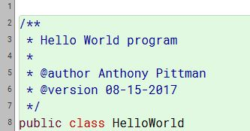

1. Now we will create the actual program. We will define a new method called main() by writing a **method signature** for it like so:

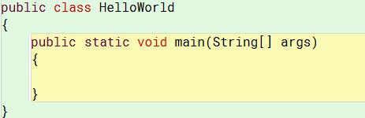

A **method** is a block of code executed by a Java program. All the work of the program is done by methods that are associated with classes. You can think of the class as a collection of methods.

A **method signature** consists of several parts that will be explained later. The method main() is a special method - it’s the one that Java attempts to execute when a program is run by a user. It always has the signature public static void main(String[] args). You can remember this with the acronym PSVM. Methods, like classes, are opened and closed using curly braces.

1. Now we need to write executable code inside the method. Here’s the code:

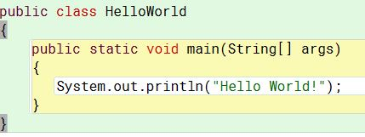

1. In the editor, click **Compile**. If there are no errors, you should see: ***“Class compiled – no syntax errors”***. If not, check to see if your code matches exactly. All executable code in Java ends with a semicolon (**;**)
2. Close the source code and go back to the project window.
3. Find the HelloWorld class, right click it, and select the main() method from the menu. BlueJ opens a method call window - click OK without entering anything and the method will execute. Hello World!
4. Select **Options** > **Clear screen at method call**. Call the method again to confirm that the screen is clearing.